Java experiment -1

Steps followed for installing java development kit(JDK)

1. Installing (JDK) through oracle.

2.Setting path variable.

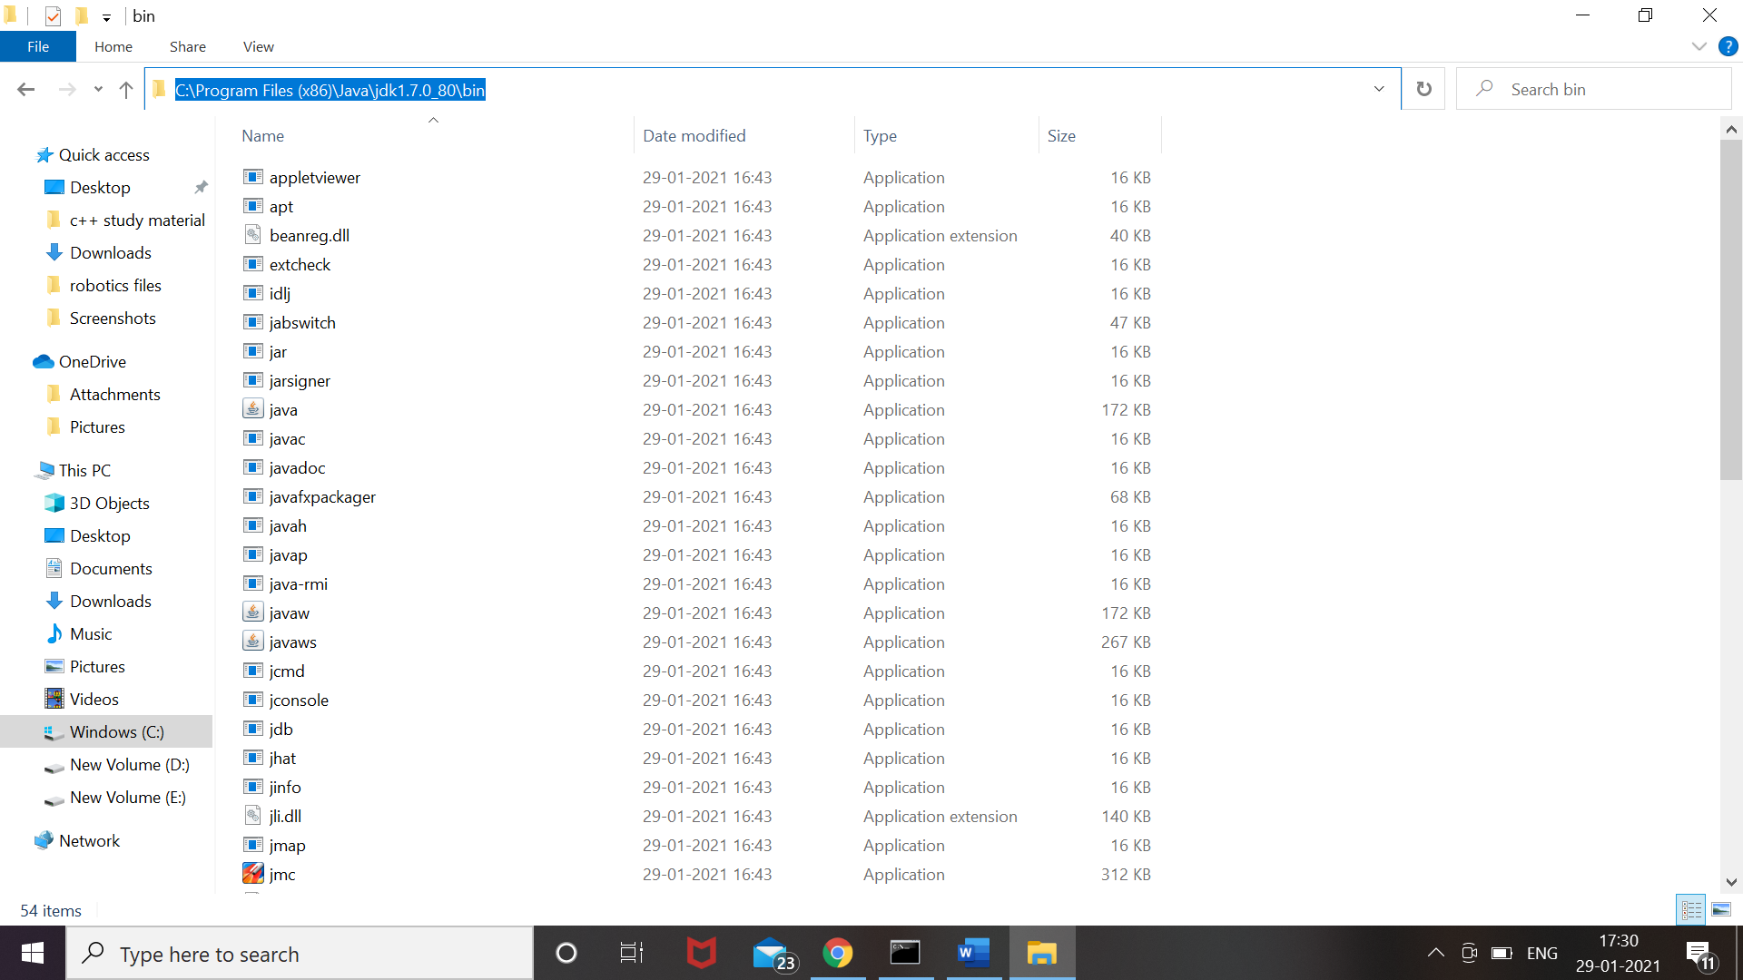

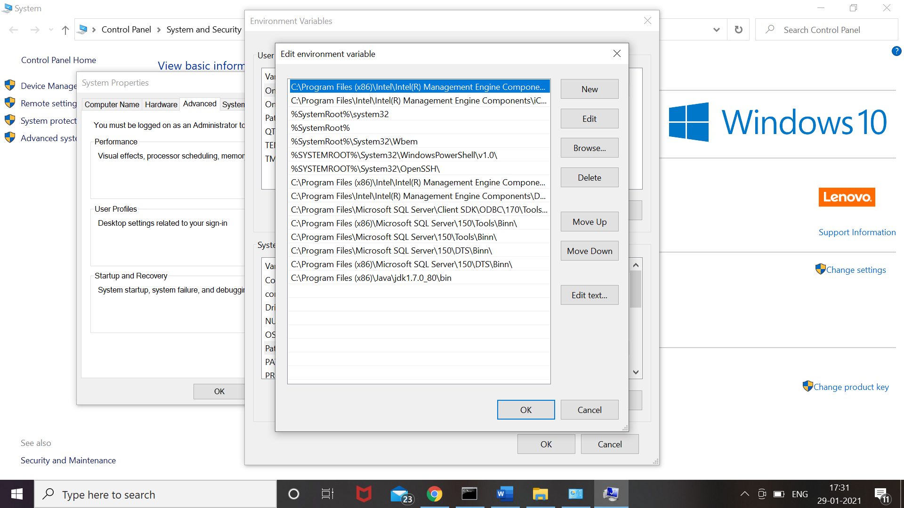

3.Writing “hello world” java program on notepad.



4. Compiling and running this program.

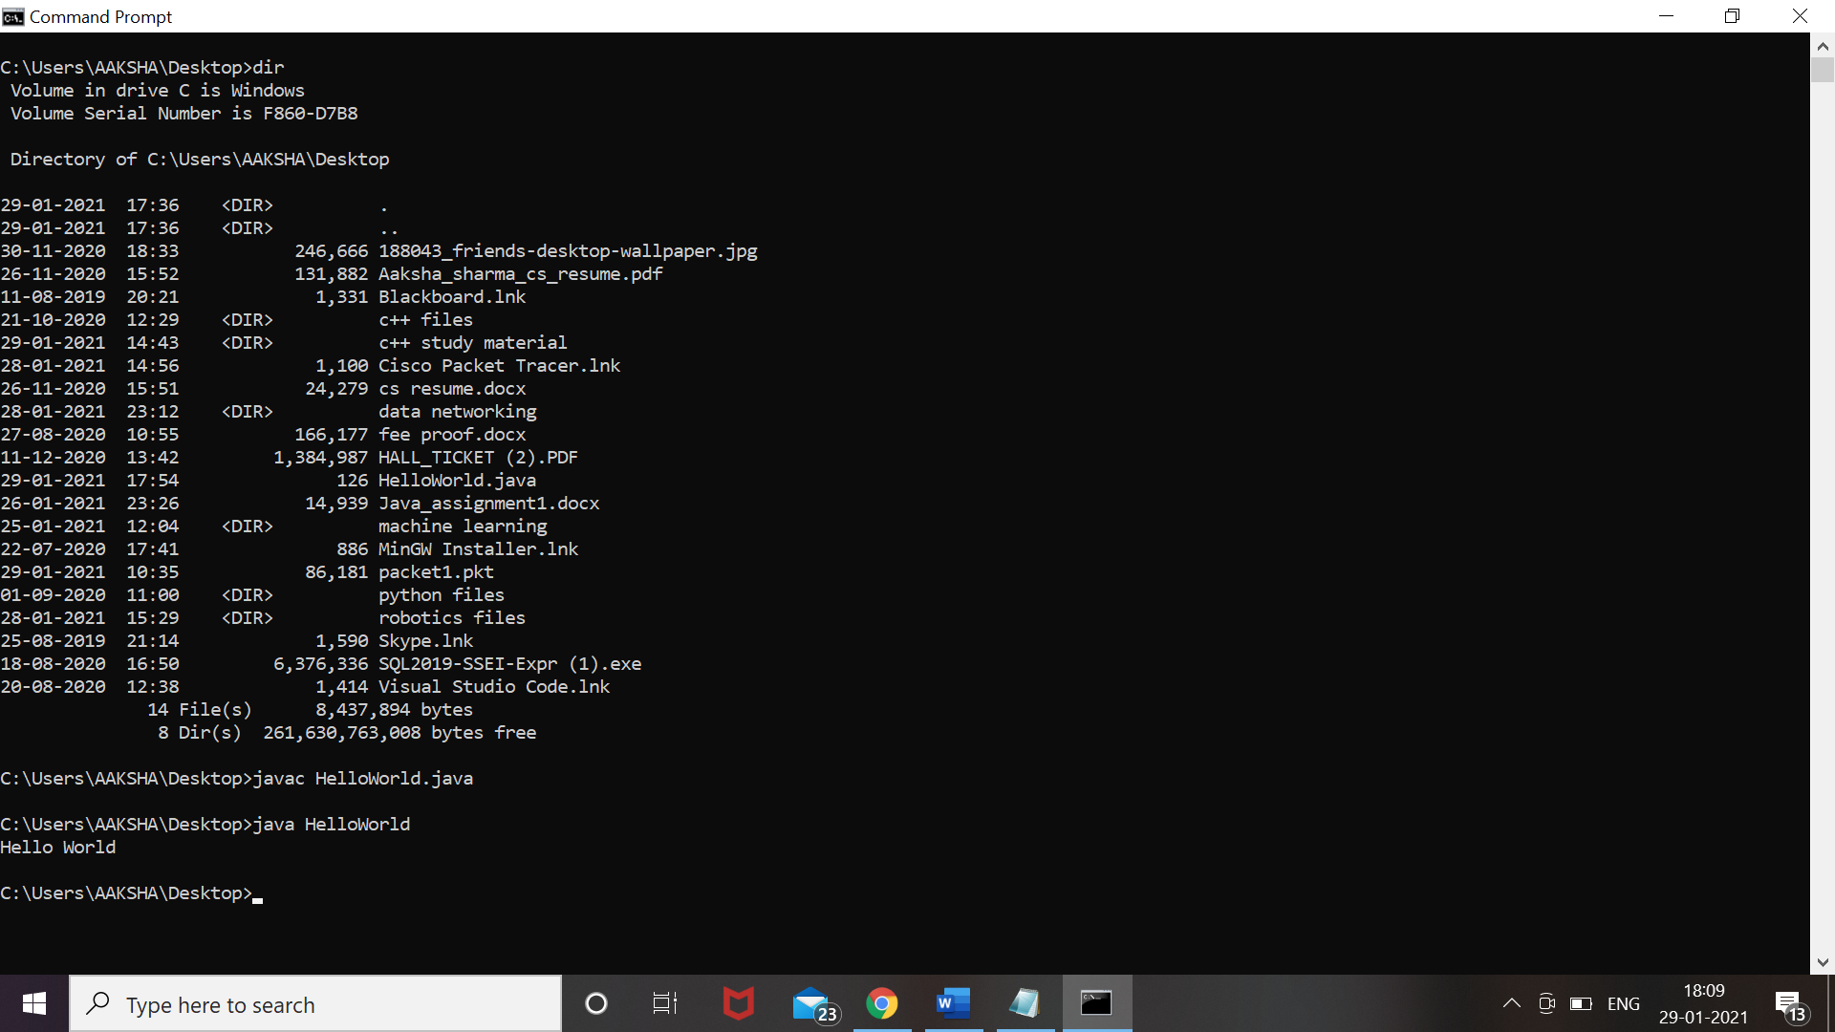

(compilation and execution done successfully!)

Downloading eclipse: -